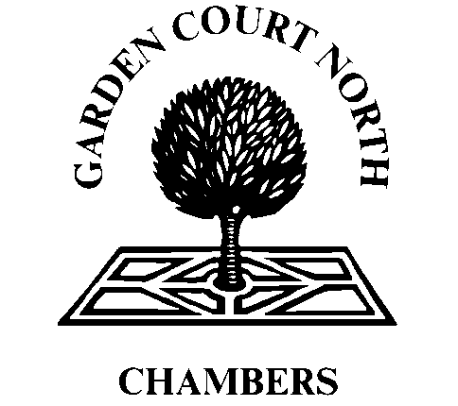

Garden Court North Chambers Terms on Inter Partes Costs

Within 7 days of a claim settling on an inter partes basis, we request to be informed in writing of the date and the terms of settlement. At this stage, a member of the Practice Management Team will obtain Counsel’s final billing and will provide you with a final inter partes fee note.

Chambers are to be informed within 7 working days of any interim or final costs order made by the Court when inter partes costs are payable.

Chambers are to be provided with a copy of the sealed order from the court within 7 working days of service of the order by the Court, including any terms for an interim costs order. Details in relation to any legal aid statutory charge which may apply to an interim or final costs order should be included.

Within 7 working days Chambers are to be informed in writing as to the date a completed bill of costs has been served on the opponent together with a copy of the bill.

Chambers are to be informed of any offers to settle inter partes costs by agreement in advance of all negotiations or agreements to settle. Express consent of instructed Counsel must be obtained to the contrary.

Within 48 hours of receipt of Points of Dispute, Chambers should be provided with a copy of the same together with conformation of the deadline for Counsel’s response.

On assessment or agreement of inter partes costs Chambers are to be informed in writing within 7 working days of the determination and be provided with a copy of any order or written agreement as to payment of inter parte costs.

Chambers are to be informed in writing of the date the sum of inter partes costs is due to be paid into the client account and Counsel’s fees should be settled within 30 days of receipt of cleared funds in accordance with the Standard Contractual Terms for the Supply of Legal Services by Barristers to Authorised Persons 2012 (updated for the GDPR 2018)

Correspondence in relation to inter partes costs should not be sent directly to Counsel. Please ensure that the Practice Management Team is copied into all correspondence at fees@gcnchambers.co.uk

